**[Dry Bulb, Wet Bulb and Dew Point Temperatures](https://www.engineeringtoolbox.com/dry-wet-bulb-dew-point-air-d_682.html" \o "dry wet dew bulb point temperature)**

**Dry Bulb, Wet Bulb and Dew Point temperatures are important to determine the state of humid air**

(<https://www.engineeringtoolbox.com/dry-wet-bulb-dew-point-air-d_682.html>)

The **Dry Bulb**, **Wet Bulb** and **Dew Point** temperatures are important to determine the state of humid air. The knowledge of only two of these values is enough to determine the state of the moist air - including the content of water vapor and the sensible and latent energy (enthalpy) in the air.

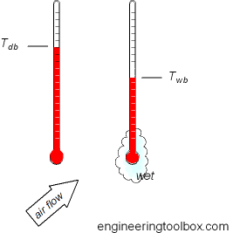

### Dry Bulb Temperature - Tdb

The Dry Bulb temperature, usually referred to as "air temperature", is the air property that is most commonly used. When people refer to the temperature of the air they are normally referring to the dry bulb temperature.

The Dry Bulb Temperature refers basically to the ambient air temperature. It is called "Dry Bulb" because the air [temperature](https://www.engineeringtoolbox.com/temperature-d_291.html) is indicated by a thermometer not affected by the moisture of the air.

Dry-bulb temperature - Tdb, can be measured using a normal thermometer freely exposed to the air but shielded from radiation and moisture. The [temperature](https://www.engineeringtoolbox.com/temperature-d_291.html) is usually given in degrees Celsius (oC) or degrees Fahrenheit (oF). The SI unit is Kelvin (K). Zero Kelvin equals to -273oC.

The dry-bulb temperature is an indicator of heat content and is shown along the bottom axis of the [psychrometric chart](https://www.engineeringtoolbox.com/psychrometric-chart-d_816.html" \o "psychrometric chart) or along the left side of the [Mollier diagram](https://www.engineeringtoolbox.com/psychrometric-chart-mollier-d_27.html" \o "Mollier diagram). Constant dry bulb temperatures appear as vertical lines in the psychrometric chart or horizontal lines in the Mollier diagram.

### Wet Bulb Temperature - Twb

The **Wet Bulb** temperature is the adiabatic saturation temperature.

Wet Bulb temperature can be measured by using a thermometer with the bulb wrapped in wet muslin. The adiabatic evaporation of water from the thermometer bulb and the cooling effect is indicated by a "wet bulb temperature" lower than the "dry bulb temperature" in the air.

The rate of evaporation from the wet bandage on the bulb, and the temperature difference between the dry bulb and wet bulb, depends on the humidity of the air. The evaporation from the wet muslin is reduced when air contains more water vapor.

The Wet Bulb temperature is always between the Dry Bulb temperature and the Dew Point. For the wet bulb, there is a dynamic equilibrium between heat gained because the wet bulb is cooler than the surrounding air and heat lost because of evaporation. The wet bulb temperature is the temperature of an object that can be achieved through [evaporative cooling](https://www.engineeringtoolbox.com/evaporative-cooling-d_698.html), assuming good air flow and that the ambient air temperature remains the same.

By combining the dry bulb and wet bulb temperature in a [psychrometric chart](https://www.engineeringtoolbox.com/psychrometric-chart-d_816.html" \o "psychrometric chart) or [Mollier diagram](https://www.engineeringtoolbox.com/psychrometric-chart-mollier-d_27.html" \o "Mollier diagram) the state of the humid air can be determined. Lines of constant wet bulb temperatures run diagonally from the upper left to the lower right in the [Psychrometric chart](https://www.engineeringtoolbox.com/psychrometric-chart-d_816.html" \o "psychrometric chart).

### Dew Point Temperature - Tdp

The **Dew Point** is the temperature where water vapor starts to condense out of the air (the temperature at which air becomes completely saturated). Above this temperature the moisture stays in the air.

* if the dew-point temperature is close to the dry air temperature -  the relative humidity is high
* if the dew point is well below the dry air temperature - the relative humidity is low

If moisture condenses on a cold bottle taken from the refrigerator the dew-point temperature of the air is above the temperature in the refrigerator.

The Dew Point temperature is always lower than the Dry Bulb temperature and will be identical with 100% relative humidity (the air is at the saturation line). As air temperature changes the Dew Point tends to remain constant unless water is added or removed from the air.

The Dew Point temperature can be measured by filling a metal can with water and some ice cubes. Stir by a thermometer and watch the outside of the can. When the vapor in the air starts to condensate on the outside of the can, the temperature on the thermometer is pretty close to the dew point of the actual air.

The Dew Point is given by the saturation line in the [psychrometric chart](https://www.engineeringtoolbox.com/psychrometric-chart-d_816.html" \o "psychrometric chart).

### Dew Point Temperature Charts

Dew point temperatures from dry and wet bulb temperatures are indicated in the charts below.

### Dew Point Temperature Charts

* [Dew Point Temperature Chart - SI units](https://www.engineeringtoolbox.com/docs/documents/682/dry_wet_bulb_dew_point_deg_C.pdf)

[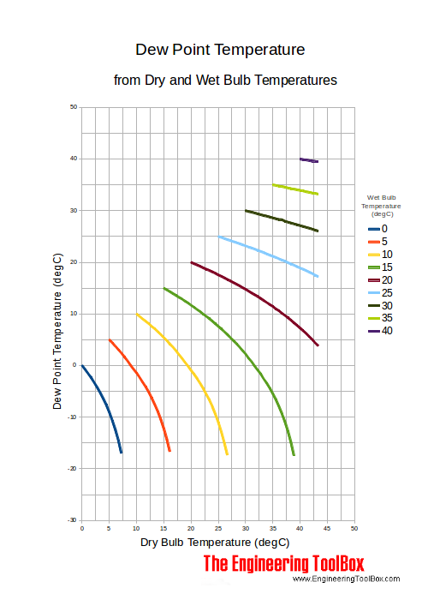](https://www.engineeringtoolbox.com/docs/documents/682/dry_wet_bulb_dew_point_deg_C.pdf)

* [Dew Point Temperature Chart - Imperial units](https://www.engineeringtoolbox.com/docs/documents/682/dry_wet_bulb_dew_point_deg_F.pdf)

[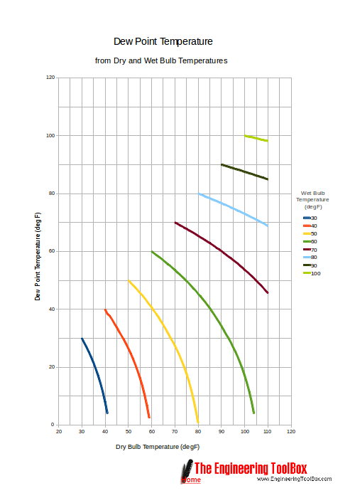](https://www.engineeringtoolbox.com/docs/documents/682/dry_wet_bulb_dew_point_deg_F.pdf)

Dew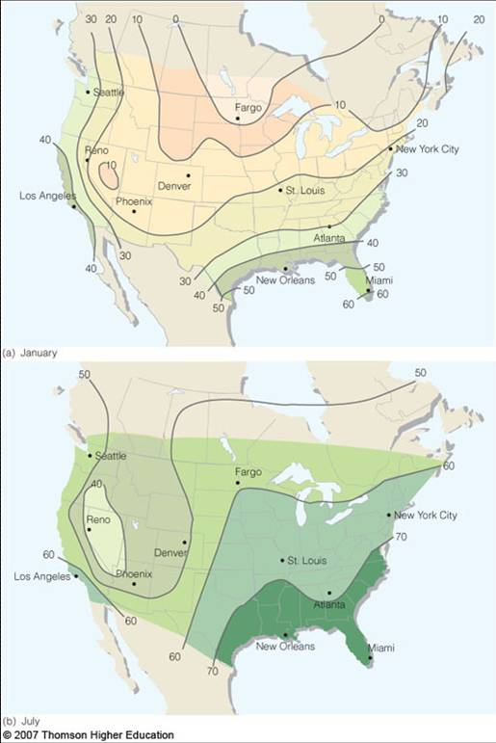 point temperatures – January and July

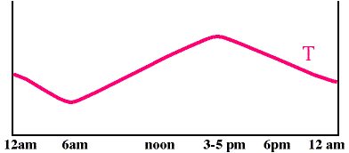

Relative humidity during a 24 hour day – example

**Relative Humidity**

* Most common variable used to describe atmospheric moisture
* RH = water vapor content / water vapor capacity
* RH = vapor pressure/saturation vapor pressure = e/es
* or RH = mixing ratio/saturation mixing ratio

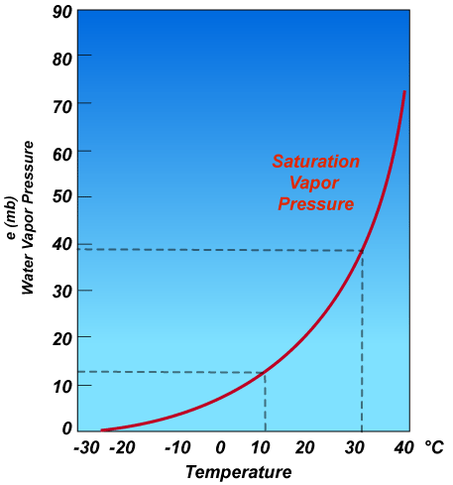

[WRAL WEATHERCENTER BLOG](https://www.wral.com/weather/blog/1028424/)

# Wet bulb temperature vs dew point differences explained

Posted November 3, 2016

|  |  |  |  |  |  |  |  |  |  |  |  |  |  |  |  |  |  |
| --- | --- | --- | --- | --- | --- | --- | --- | --- | --- | --- | --- | --- | --- | --- | --- | --- | --- |
| |  |  |  |  |  | | --- | --- | --- | --- | --- | | |  |  |  | | --- | --- | --- | |  |  |  | | **0** | | |  |  |  | | --- | --- | --- | |  |  |  | |  | |  |  |  |  |  | | --- | --- | --- | --- | --- | | |  |  |  | | --- | --- | --- | |  |  |  | |  | |  |

21 Reactions

## Is wet bulb temperature the same as dew point?

Mike Moss: In a saturated air parcel (with relative humidity 100%) the wet bulb, dry bulb and dew point temperatures are all the same. In a drier parcel of air, the dry bulb is just the air temperature which will be the warmest of the three variables. The dew point will be the lowest number, and the wet bulb will fall between those two.

If you were to cool that drier air without adding or removing any water vapor, the dew point would remain constant while the dry bulb and wet bulb temperatures would fall (this happens in the atmosphere when air near the surface cools at night to the point that fog or dew develops, or when an air parcel rises and cools via expansion to the point where saturation occurs and clouds form).

If you were to add water vapor vapor (but not by evaporation directly within the air parcel), the dew point and the wet buld would climb, while the dry bulb temperature would stay the same.

If you were to evaporate directly within the air parcel enough water vapor to raise the relative humidity to 100%, the wet bulb would stay the same, while the dew point would climb and the dry bulb temperature would fall (this is a common process in the atmosphere that often causes rapid cooling when precipitation falls into an initially dry layer of air).

(<https://www.wral.com/wet-bulb-temperature-vs-dew-point-differences-explained/1254745/>)

**Chillers:**

<https://en.wikipedia.org/wiki/Chiller>

# How a Chiller, Cooling Tower and Air Handling Unit work together

By

[**Paul Evans**](http://theengineeringmindset.com/author/paulevans/)

 -Sep 26, 2017 <http://theengineeringmindset.com/chiller-cooling-tower-air-handling-unit-work-together/>

[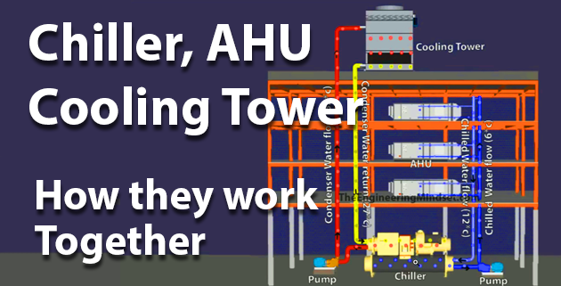](http://theengineeringmindset.com/wp-content/uploads/2017/09/How-cooling-tower-ahu-and-chiller-work-together.png)How cooling tower, AHU and chiller work togethe

How does a Chiller, Cooling Tower and Air Handling Unit work together to provide air conditioning (HVAC) to a building. In this article we will be covering this topic to understand the basics of HVAC central plant.  
http://theengineeringmindset.com/wp-content/uploads/2017/09/youtubeicon2.png**Scroll to the bottom to watch the video tutorial on this subject**

How a chiller cooling tower and AHU work together

The main system components of the central cooling plant are the:

* Chiller
* Air Handling Unit (AHU)
* Cooling Tower
* Pumps

The chiller will usually be located either in the basement or on the roof and this depends on what type of chiller is used. Roof top chillers are usually “Air cooled” whereas basement chillers are usually “Water cooled” but they both perform the same function which is to generate cold water for air conditioning by removing the unwanted heat from the building. The only difference is how the chiller discards the unwanted heat.

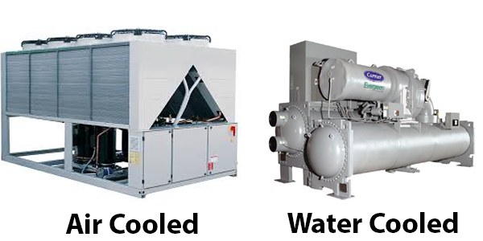Air cooled chiller and water cooled chiller

[Air cooled chillers](http://theengineeringmindset.com/air-cooled-chillers-work/) will use fans to blow cool ambient air over their condenser to remove heat from the system, this type does not use a cooling tower. You can learn about this system and watch the video tutorial by [clicking here](http://theengineeringmindset.com/air-cooled-chillers-work/). For the remainder of this article we will focus on water cooled chillers and cooling towers.

The water cooled chiller has two large cylinders, one is called the evaporator and the other is called the condenser.

Mid ad

**Chilled water:**  
The evaporator of the chiller is where the “chilled water” is generated. The “chilled water” leaves the evaporator at around 6°C (42.8°F) and is pushed around the building by the chilled water pump. The chilled water flows up the height of the building to each floor in pipes known as “risers”. These pipes are known as risers no matter if the water is flowing upwards or downwards within them.

The chilled water branches off the risers into smaller diameter pipes which head to the fan coil units (FCU’s) and Air Handling Units (AHU’s) to provide air conditioning. The AHU’s and FCU’s are basically boxes with fans inside that suck air in from the building and push it across the heating or cooling coils to change the temperature of the air and then push this air back out into the building. The chilled water enters the AHU/FCU and passes through the cooling coil (a series of thin pipes) where it will absorb the heat of the air blowing across. The chilled water heats up and the air blowing across it cools down. When the chilled water leaves the cooling coil it will now be warmer at around 12°C (53.6°F). The warm chilled water then heads back to the evaporator, via the return riser, and once it enter the evaporator a refrigerant will absorb the unwanted heat and move this over to the condenser. The chilled water will then leave cool again, ready to circulate around the building and collect more unwanted heat. Note: the chilled water is referred to as “chilled water” no matter if it is warm or cool.

**Condenser water:**  
The condenser of the chiller is where the unwanted heat is collected before being sent to the cooling towers. A refrigerant passes between the evaporator and the condenser to move all the unwanted heat. Another loop of water, known as “condenser water”, passes in a loop between the condenser and the cooling tower. The refrigerant collects the heat from the “chilled water” loop in the evaporator and moves this to the “condenser water” loop in the condenser.

The condenser water enters the condenser at around 27°C (80.6°F) and will pass through, collecting heat along the way. By the time it leaves the condenser it will be around 32°C (89.6°F). The condenser water and the refrigerant never mix, they are always separated by the pipe wall, heat just transfers through the wall. Once the condenser water has passed through the condenser and picked up the unwanted heat, it will head up to the cooling towers to dump this heat and return cooler ready to collect more heat.

Location of cooling towers

**Cooling tower:**  
The cooling tower is usually located up on the roof and is the final destination for the unwanted heat in the building. The cooling tower contains a large fan which blows air through the unit. The condenser water is pumped up to the cooling towers and it is sprayed into the air stream. The cool ambient air will enter and come in direct contact with the spray of condenser water (in an open cooling tower) this will allow the heat of the condenser water to transfer into the air and this air is then blown out into the atmosphere. The condenser water then collects and heads back to the chillers condenser ready to collect more heat. Check out our special tutorial on cooling towers here.

### Share this: